AHFA DMS How to Create Orgingation Contacts

Step 1:
- Go to “My Profile” to access the Contacts page.
- Click “Contacts” within the Organization section as shown below.

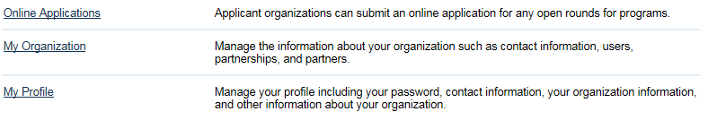

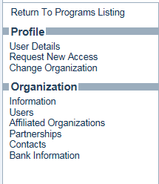

See examples from the screens below

- Click “Add New. “
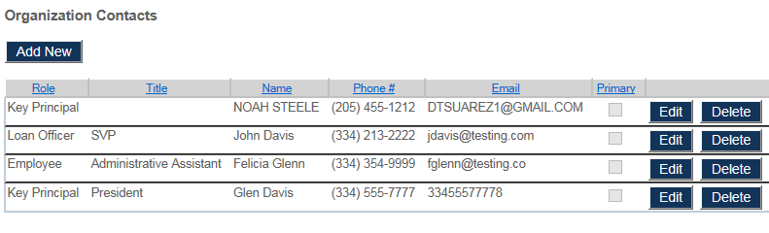

- Complete all fields as indicated below. (Don’t forget to choose your role).
- Click “Add.”
- Save your changes.

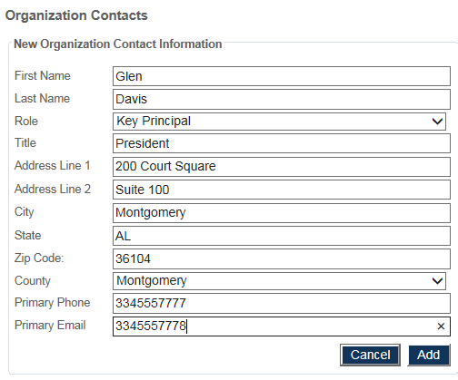
Complete all fields here.

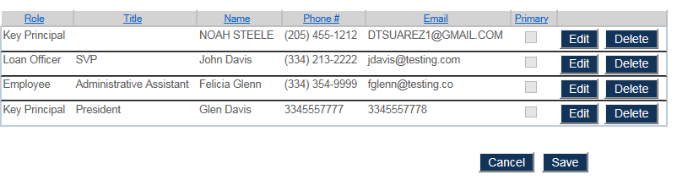
See New Contact added here,

Step 2: Editing a contact:
- Click “Contacts” within the Organization section as shown below.
- Click edit.

- The navigation pane below shows this user is updating the street address.
- Once the changes have been made click “Update.”
- The second navigation pane below show the contact has been edited and updated. 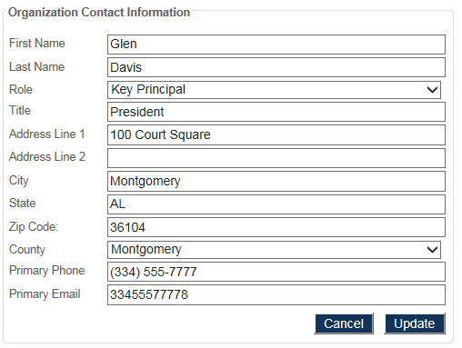
Edit the necessary fields.

