AHFA Online Registration
- As a first time user for this web site, you must register and have it approved by AHFA.
- Go to https://multifamily.ahfa.com/AuthorityOnline/Default.aspx, this is the logon page for AHFA Online, this can be found going through the www.ahfa.com
- If you have not registered, you will need to click “New User? Register Here”; the owner must register first.

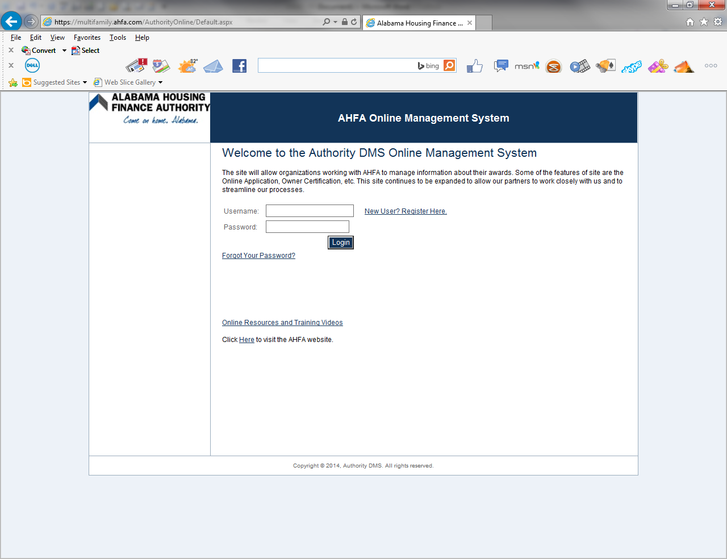

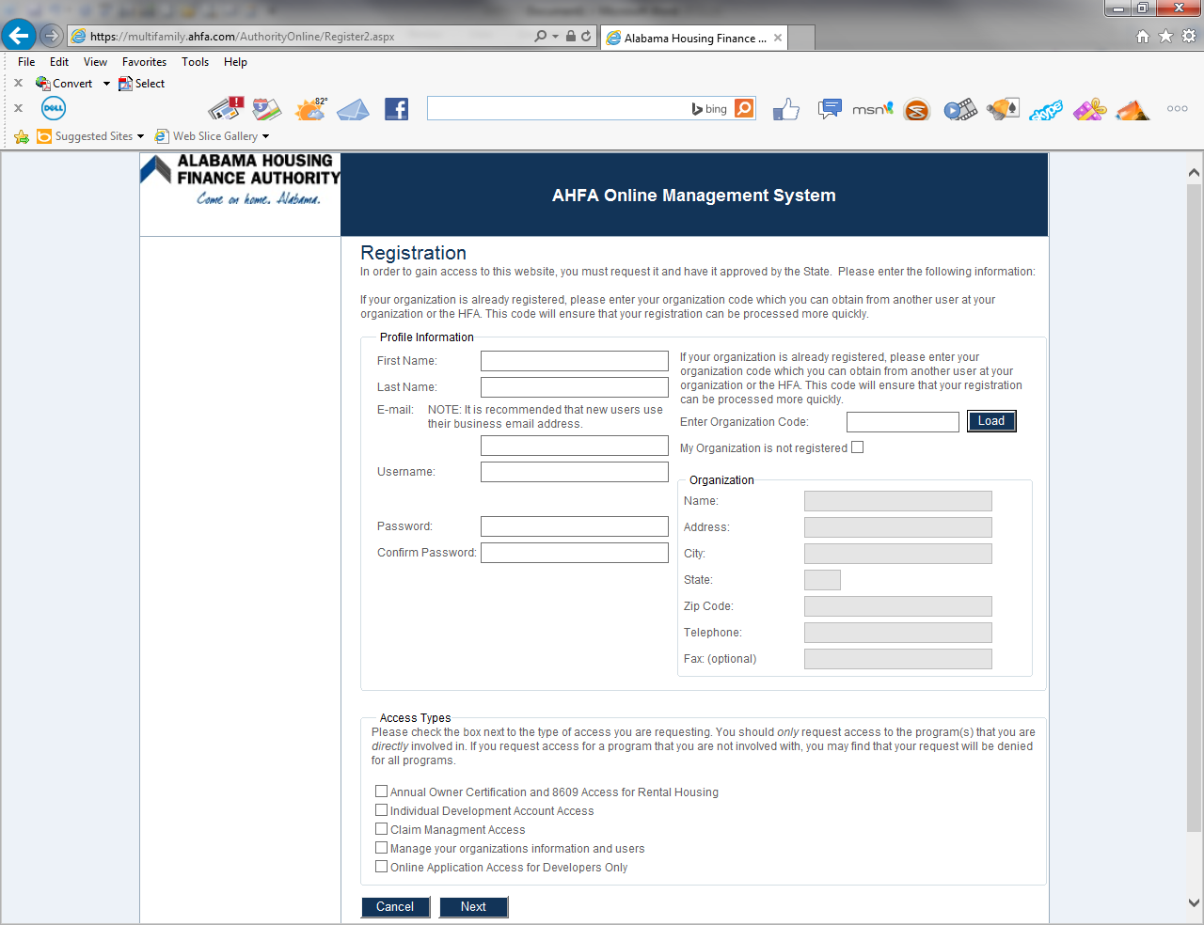
All fields (other than fax) must be completed.
The phone number must be entered in this format: (999) 999-9999.
Your username will be your email address.
Your password must be at least 7 characters and must contain at least one number. It can contain letters, number and the characters (*, #, or @).
If you have not registered your organization, please check the box.
If you have registered, you will enter your Organization Code and your registration information will appear.
When choosing which Access Type, you will need to check the box’s beside “Annual Owner Certification and 8609 Access for Rental Housing” and “Manage your organizations information and users” and then click “Next”.
By choosing this these options, the system will allow you to enter tenant data, complete Annual Owner Certifications, and choose who you will allow to access your properties.

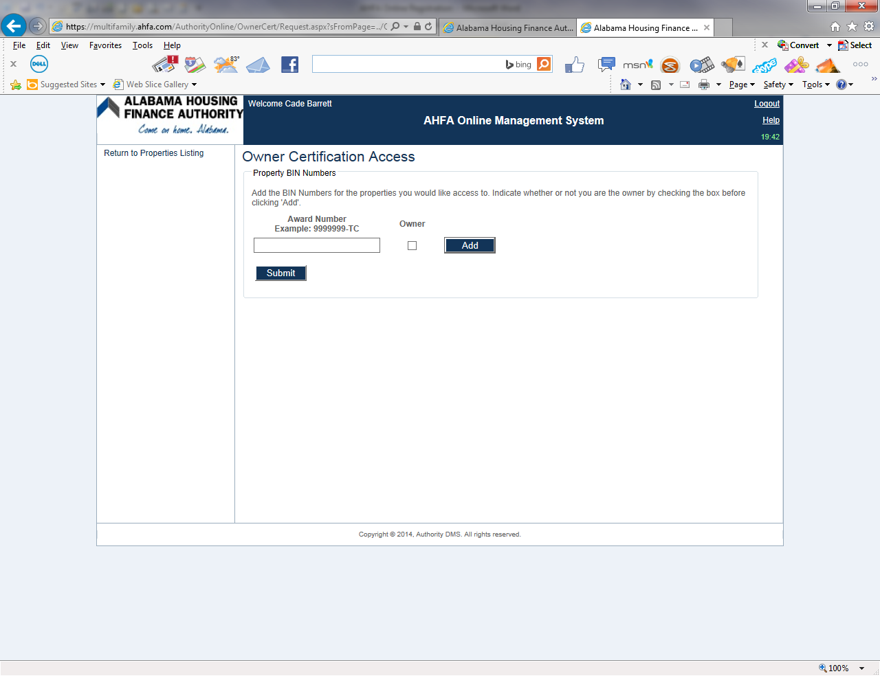
You will need to enter the Award Number in this format: 9999999-TC.
Check that you are the owner and click Add.
This process will need to be repeated for each property.
After all properties are entered, click submit.
If entered correctly, you will see a message that says “Request submitted successfully”.
You will receive an email from AHFA notifying you if the Access Request has been approved or denied.
At this point your management company (AHFA Online User) will need to register by doing all the above steps except when asked if they are the owner, they will choose property manager and when asked which Access Types, they will choose “Annual Owner Certification and 8609 Access for Rental Housing”.
As the Owner, you will receive the request to approve or deny the property management’s (users) request to access the property.
There are other instructions for the online system provided at this website address https://www.ahfa.com/multifamily/compliance/online_management_system.aspx, which is on AHFA’s website.
When you begin to enter household information, please start from what your property looked like on January 1, 2014.
When you logon, will see a 2014 and 2015 choice for your property listings; to enter the household data for January 1, 2014, you will click on the 2014 version; to enter the household data for 2015, you will click on the 2015 version. If a household moved-in to the property before 2014 and still lives at the property, just check on the box beside “Show All Owner Certificates” and more effective dates will appear. You can select the appropriate effective date to create the move-in for the household.

